Table S1. Mean and standard error (SE) of $\sqrt{ab}$ of the fitted one-standard-deviation ellipse for each experimental condition.
Background (cd/m²) | Disparity (arcmin) | Neutral |  | Red |  | Green |  | Blue
Background (cd/m²) | Disparity (arcmin) | Mean | SE | Mean | SE | Mean | SE | Mean | SE
0 | -180 | 0.0022 | 0.0003 | 0.0029 | 0.0005 | 0.0026 | 0.0003 | 0.0023 | 0.0003
0 | -120 | 0.0021 | 0.0003 | 0.0034 | 0.0006 | 0.0031 | 0.0005 | 0.0028 | 0.0005
0 | -60 | 0.0021 | 0.0003 | 0.0037 | 0.0007 | 0.0031 | 0.0006 | 0.0026 | 0.0004
0 | 0 | 0.0021 | 0.0004 | 0.0041 | 0.0009 | 0.0034 | 0.0005 | 0.0034 | 0.0006
0 | 60 | 0.0023 | 0.0005 | 0.0037 | 0.0007 | 0.0031 | 0.0005 | 0.0030 | 0.0005
0 | 120 | 0.0021 | 0.0003 | 0.0033 | 0.0007 | 0.0030 | 0.0006 | 0.0026 | 0.0004
0 | 180 | 0.0021 | 0.0003 | 0.0032 | 0.0005 | 0.0027 | 0.0005 | 0.0023 | 0.0004
20 | -180 | 0.0017 | 0.0003 | 0.0027 | 0.0004 | 0.0025 | 0.0003 | 0.0024 | 0.0003
20 | -120 | 0.0018 | 0.0003 | 0.0030 | 0.0006 | 0.0030 | 0.0005 | 0.0027 | 0.0004
20 | -60 | 0.0019 | 0.0002 | 0.0031 | 0.0007 | 0.0032 | 0.0005 | 0.0029 | 0.0005
20 | 0 | 0.0018 | 0.0003 | 0.0035 | 0.0007 | 0.0034 | 0.0006 | 0.0033 | 0.0005
20 | 60 | 0.0018 | 0.0003 | 0.0033 | 0.0005 | 0.0029 | 0.0004 | 0.0032 | 0.0002
20 | 120 | 0.0017 | 0.0003 | 0.0033 | 0.0004 | 0.0030 | 0.0004 | 0.0029 | 0.0004
20 | 180 | 0.0016 | 0.0003 | 0.0028 | 0.0003 | 0.0027 | 0.0004 | 0.0025 | 0.0003
Table S2. Results of the polynomial trend analysis
Background (cd/m²) | Color | Quadratic Trend | $η_{p}^{2}$ (Quad) | Quadratic Coeff. [95% CI]
0 | White | F (1,6) = 0.61, p = 0.463 | 0.102 | -2.98×10⁻⁹ [-1.52×10⁻⁸, 9.24×10⁻⁹]
0 | Red | F (1,6) = 5.34, p = 0.060 | 0.890 | -3.47×10⁻⁸ [-4.92×10⁻⁸, -2.02×10⁻⁸]
0 | Green | F (1,6) = 5.50, p = 0.057 | 0.917 | -2.15×10⁻⁸ [-2.96×10⁻⁸, -1.34×10⁻⁸]
0 | Blue | F (1,6) = 4.21, p = 0.086 | 0.702 | -2.74×10⁻⁸ [-5.22×10⁻⁸, -2.73×10⁻⁹]
20 | White | F (1,6) = 4.69, p = 0.073 | 0.781 | -4.96×10⁻⁹ [-7.71×10⁻⁹, -2.20×10⁻⁹]
20 | Red | F (1,6) = 5.43, p = 0.058 | 0.905 | -2.45×10⁻⁸ [-3.44×10⁻⁸, -1.46×10⁻⁸]
20 | Green | F (1,6) = 4.02, p = 0.091 | 0.670 | -1.85×10⁻⁸ [-3.65×10⁻⁸, -5.50×10⁻¹⁰]
20 | Blue | F (1,6) = 5.08, p = 0.064 | 0.847 | -2.41×10⁻⁸ [-3.78×10⁻⁸, -1.05×10⁻⁸]

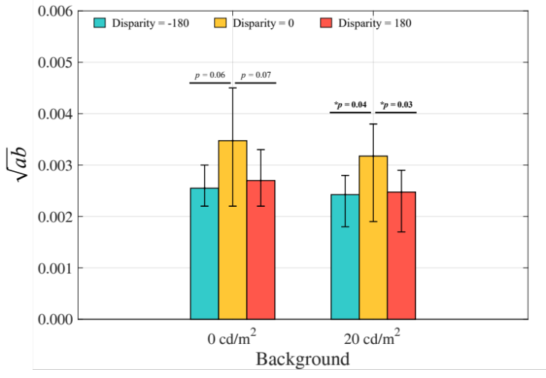
Fig. S1. Mean $\sqrt{ab}$ values of all colors for the comparison between 0° and ±180 arcmin disparity. Pairwise comparisons (paired t-tests) were performed, with statistical significance denoted by asterisks (* = p < 0.05). Error bars indicate the minimum-to-maximum range of data.

